**Power BI Vs Tableau**

Data:

* Power Query at backend for complex data processing
* Flexibility at transforming data
* Linking Data Tables

Calculation:

* quick measure, extensive calculation
* DAX

Visuals:

* Design, stories, interactions
* Dashboards

**Working with Data**

**Loading Files from Folder**

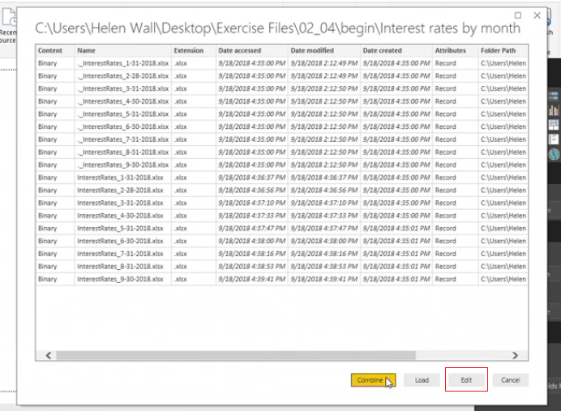

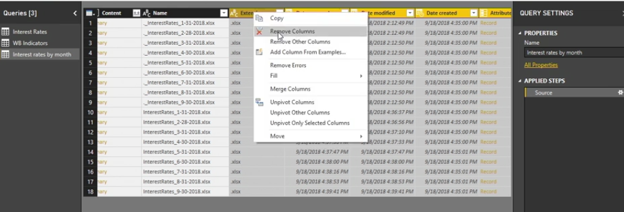

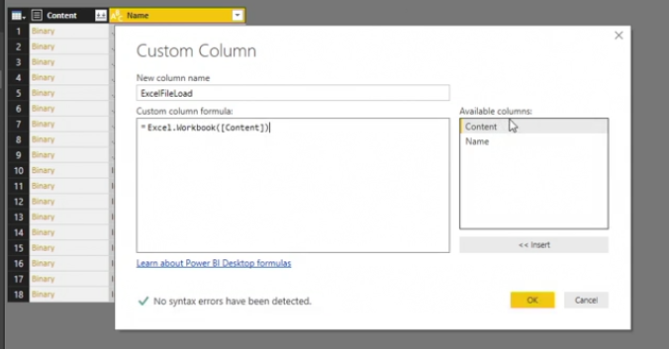

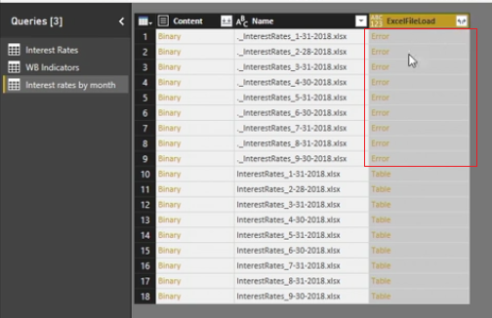

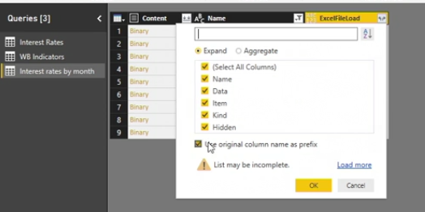

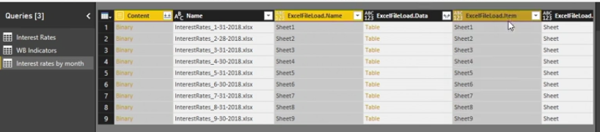

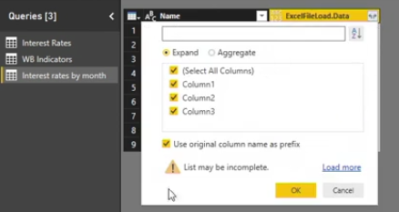

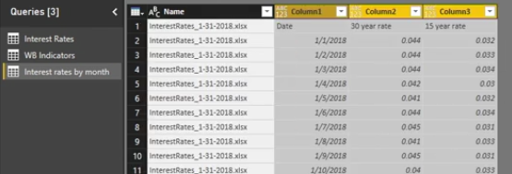

**Querying a Database**

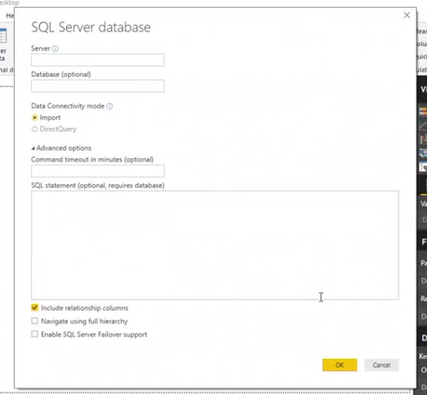

Import / Extract: import data stored in Power BI

Direct Query / Live: Data Link maintained via connection only. fastest Connection method.

Query Folding

Changes made in query editor are not seen in entire data set until we load data set to improve power query efficiently

Keep Data tables and Loop up separately

**Uploading a PDF**

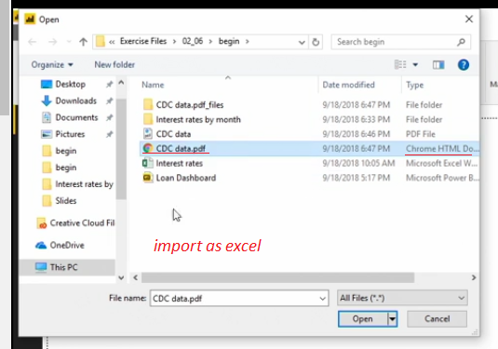

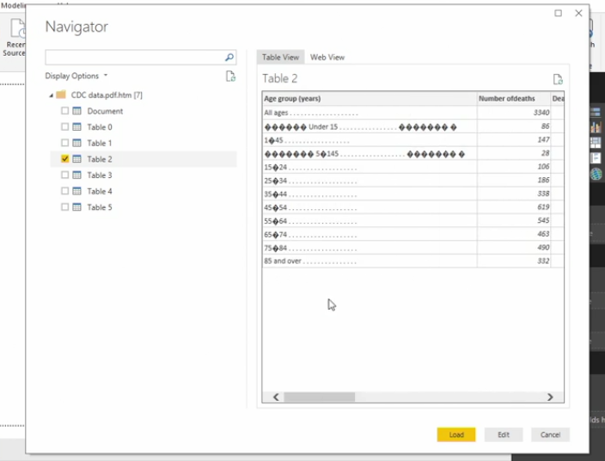

**Why is importing a PDF's data into Power BI considered a "hack" method?**

Power Query does not directly support uploading PDFs, so you can instead open it as a Word document and save it as an HTML file.

**Query Editor**

Modifying Data Tables:

* using first row as header
* Renaming columns
* removing columns
* moving columns
* filtering columns
* transpose Data

Data Type:

* Number
* Date
* Text

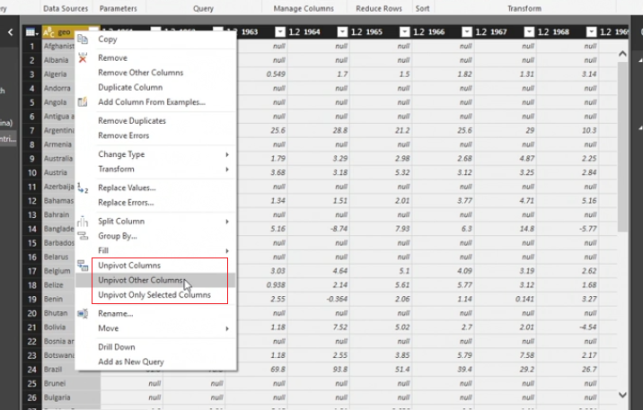

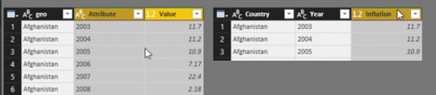

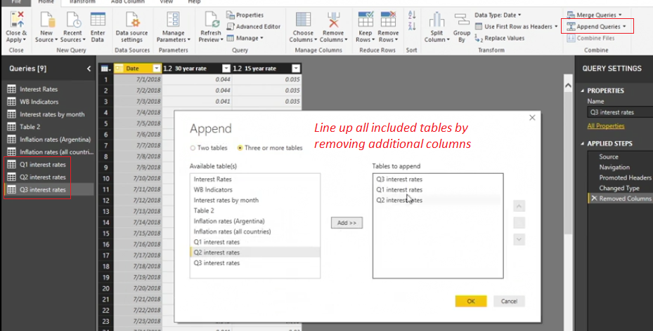

Text Formulas:

* Syntax : Capitalization
* Data Type: other columns need to be text too
* Quotation: Text written out in Quotation

Examples

LEFT : Text.Start

RIGHT : Text.End

LEN : Text.Length

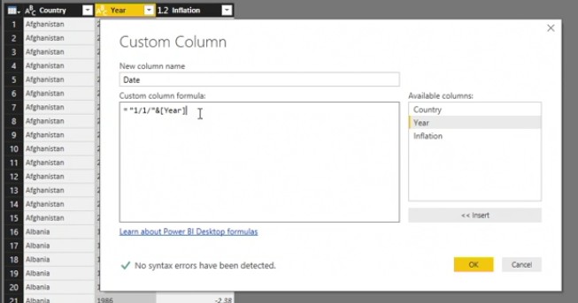

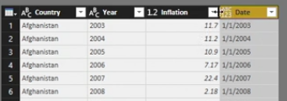

Conditional Formula:

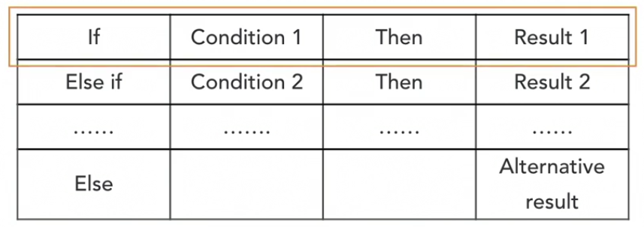

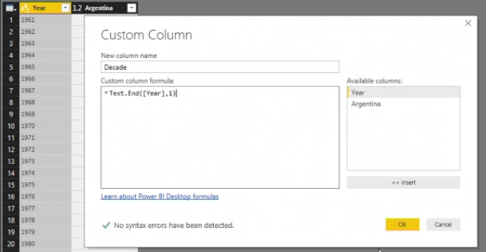

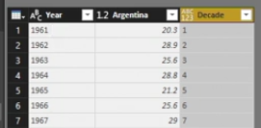

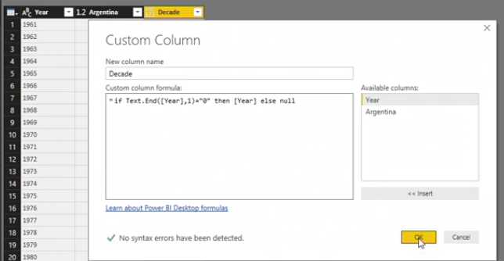

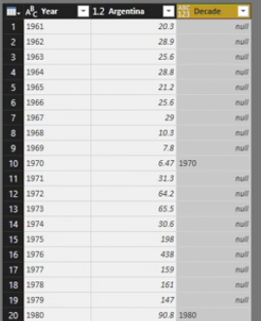

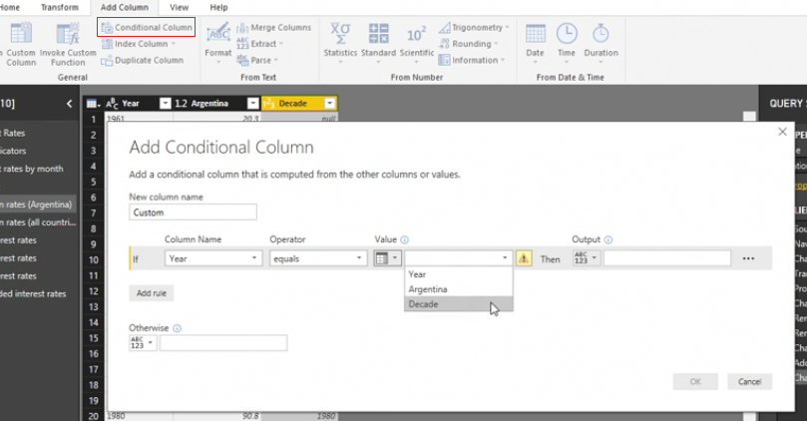

Fill Down and Fill Up

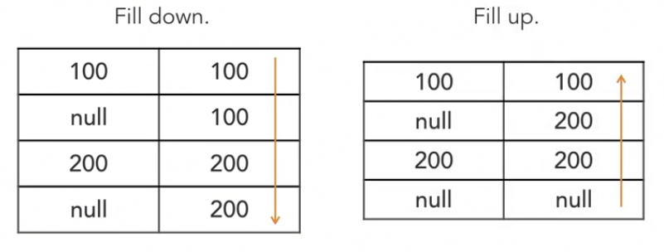

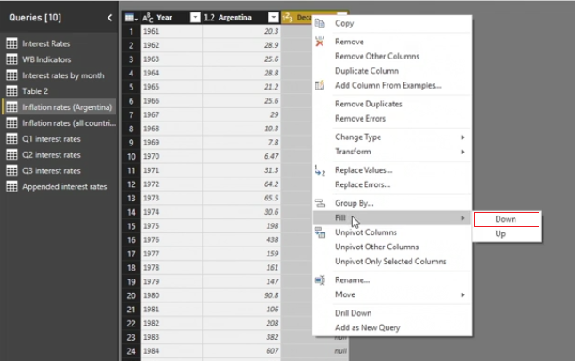

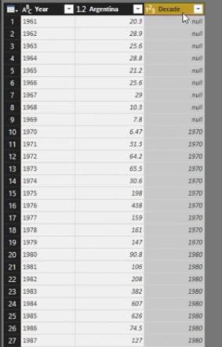

Create Calculated Column

calculate inflation rate

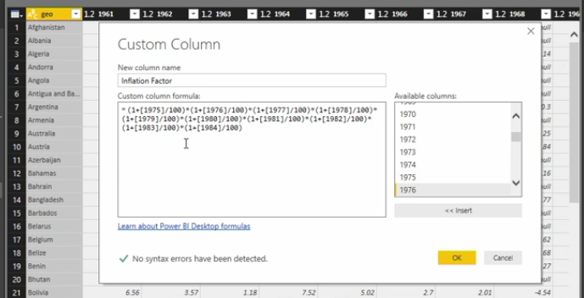

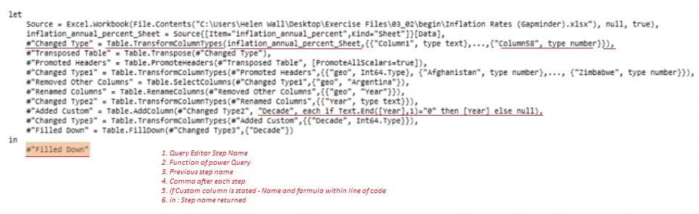

Joining Data Tables:

Data shaping is building hierarchical relationships between two or more logical entities - creating Parent Child relationship

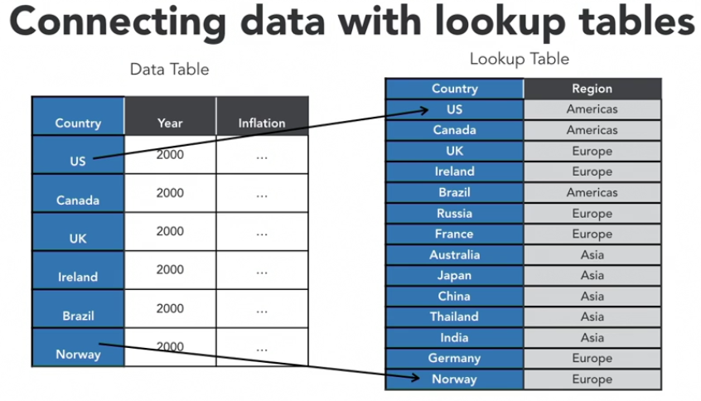

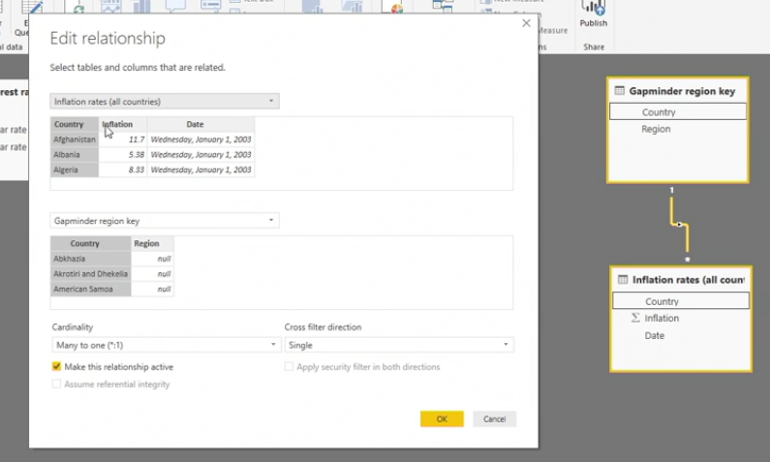

DAX:

* complexity
* Column and tables
* Formula options plus time intelligence
* limited formula input
* formulas are applied to all the rows
* DAX measures are much flexible , better than DAX calculated columns

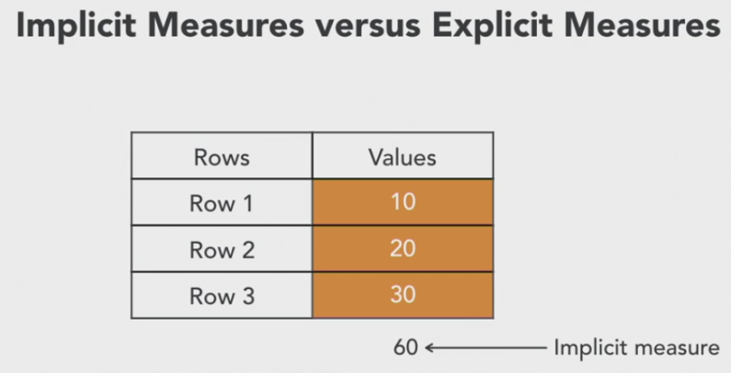 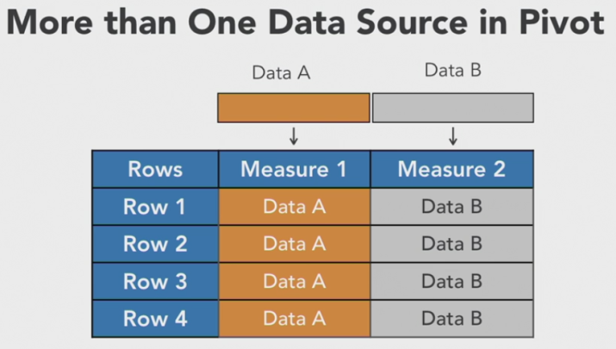

Why would you use explicit DAX measures rather than implicit measures in Power BI? When you create pivot tables, implicit measures are often inaccurate.

DAX sample

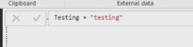

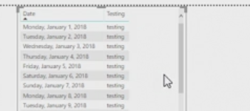

* Cells in Power BI pivot table is - Pivot Coordinate
* DAX measures are evaluated against source data, not against pivot table

measure 3 = measure 1 + measure 2

measure 3 depends on source data, not on measure 1 or measure 2

* Each measure is calculates independently
* Each pivot coordinate is evaluated in steps

DAX Process :

Step 1: Pivot coordinates are detected

Step 2: Have active rows detected in data.

Step 3: Apply arithmetic on active cells

Step 4: Result is returned. Process starts for next pivot coordinate.

Calculate function:

* No naked column - Use Calculate(Sum(Field 2)) instead Calculate(Field2)
* Fastest without filters

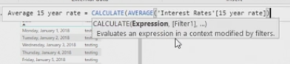

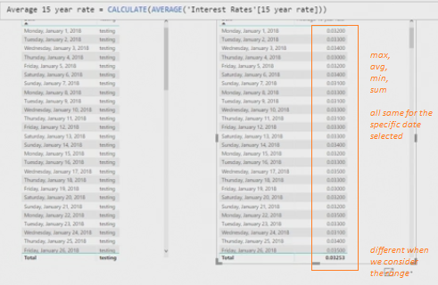

Filter with Calculate :

* Pivot coordinates are initial filters
* **Filter / equal to condition :** [measure] = calculate(sum(column), <filter 1>, <filter 2>, <filter 3>, etc.)

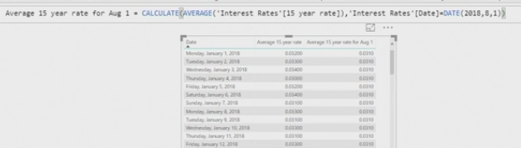

* **Not Equal :** [measure]= calculate(sum(column), status <> "Active")

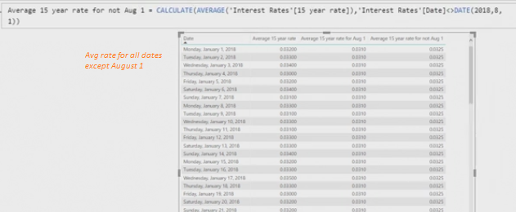

* **AND :** [measure]= calculate(sum(column), column1<> "Active", column2 = 2)

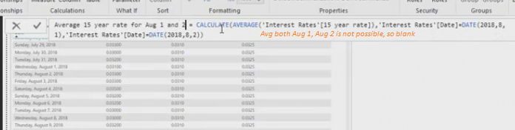

* **OR:** [measure]= calculate([measure], column1= x || column1 = y)

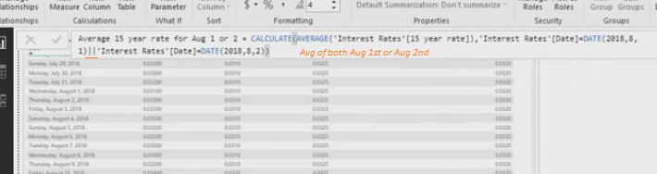

* Threshold filters with AND - Range of values :

[measure]= calculate(sum(column), amount >= 0 && amount < 100)

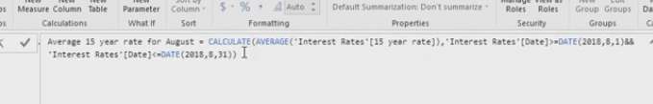

ALL function

* Removes the filter already applied in a formula
* = ALL(Column or Table name)
* Not stand alone function
* Ex: calculating percentage of parent, negating filter that is already applied

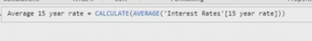

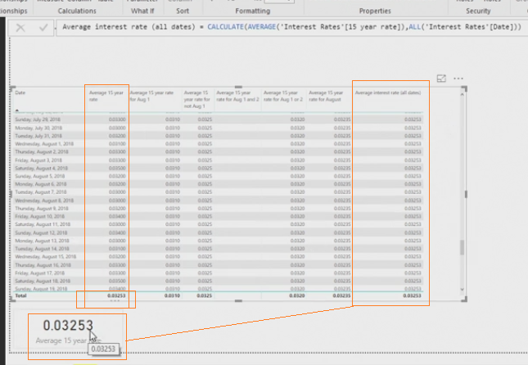

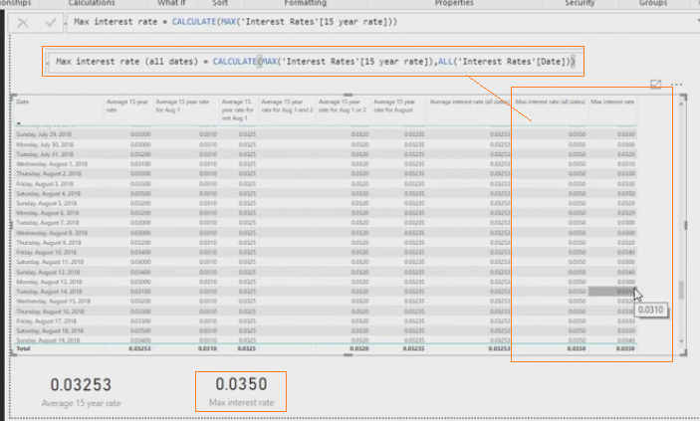

Filter Function:

= filter(<table>, <filter condition>)



Separate tables for measures

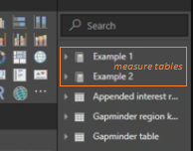

Generate series to create Table

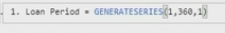

=GENERATESERIES(start value, end value, interval)

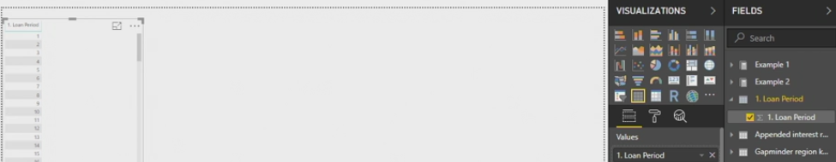

Power function

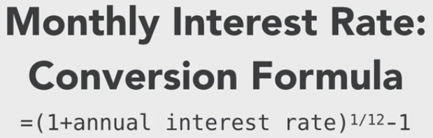

=Power(base, exponent)

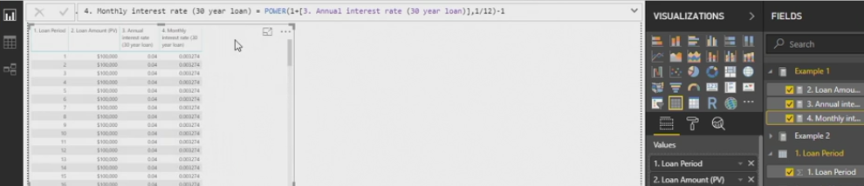

Divide function

=DIVIDE(numerator, denominator, <alternate result> : optional <alternate result>, if numerator / denominator is undefined

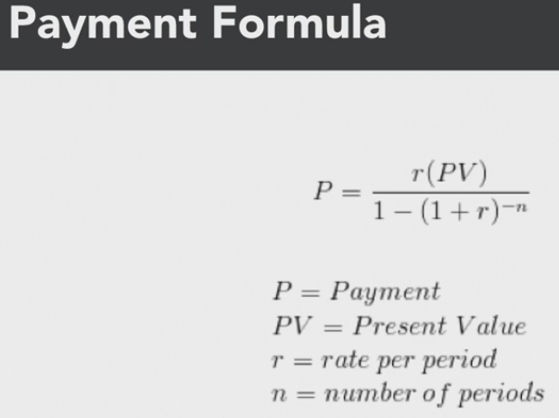

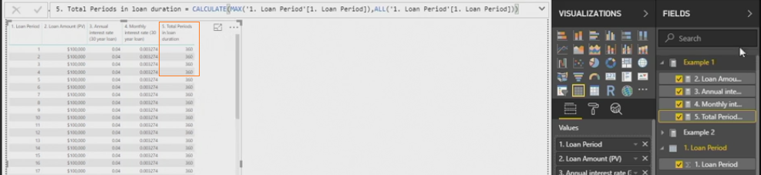

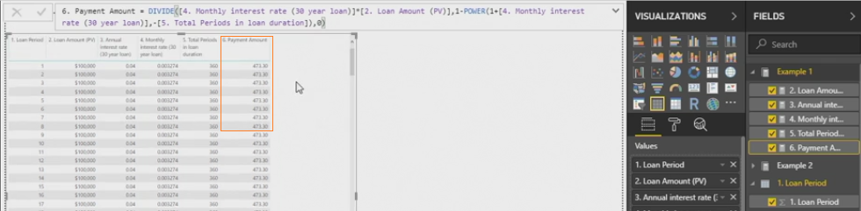

Parameter harvesting function

* Convert naked column into measure

Parameter harvesting measure = calculate(max(column name)) : calculate - best practice to include

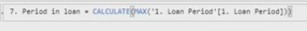

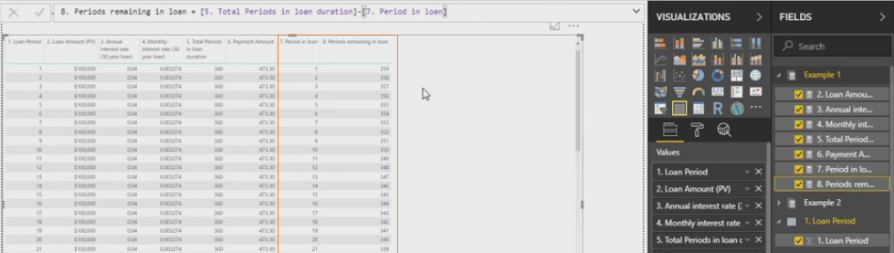

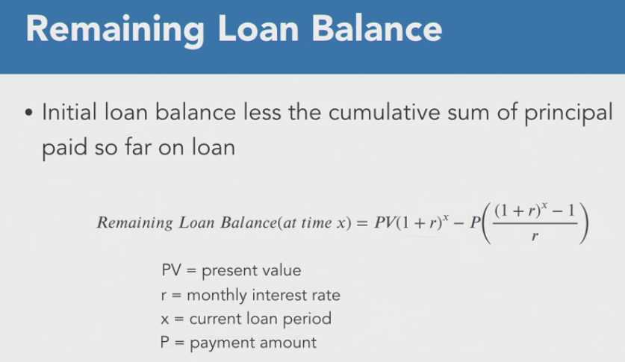



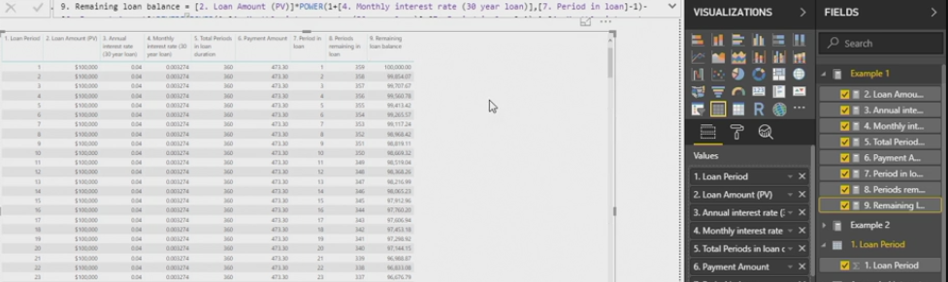

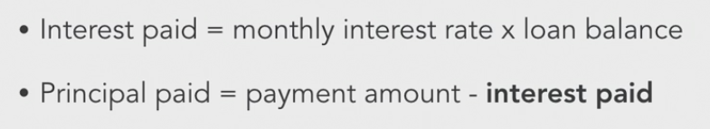



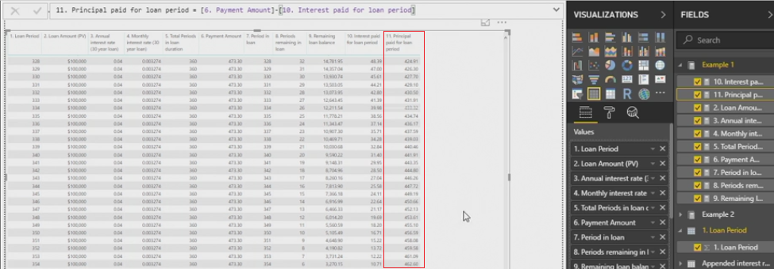

X- factor functions family : sumx, countx, productx, maxx, minx



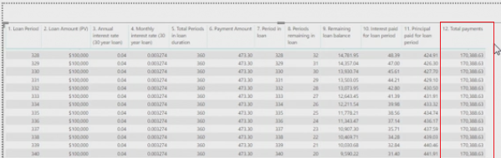

Sumx

= sumx(table/column, [measure or expression])

*: Need to setup filter conditions*

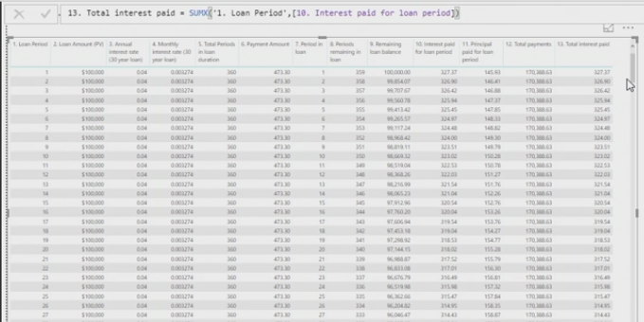

sumx with ALL

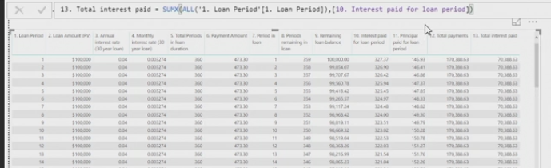

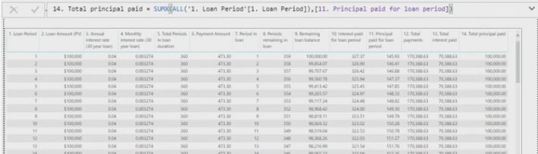

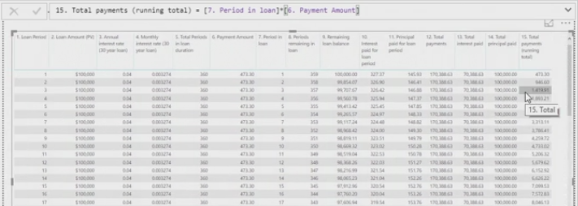

Sumx function with Ranges:

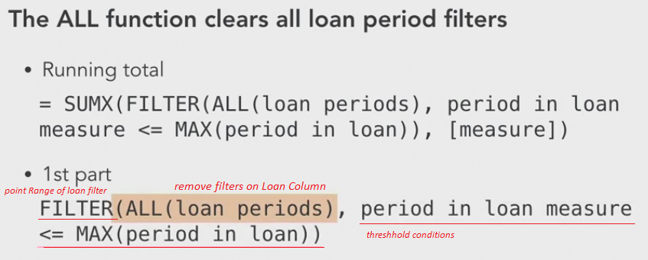



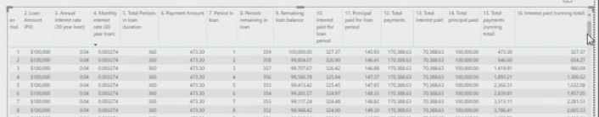



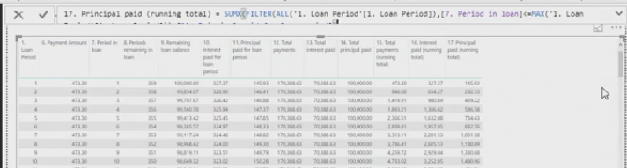

Quick measures:

* Aggregate per category
* Filters
* Time intelligence
* Totals
* mathematical operations
* Text

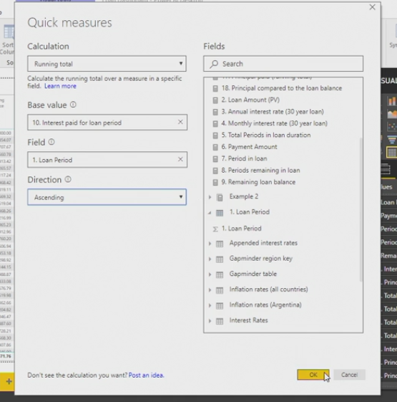

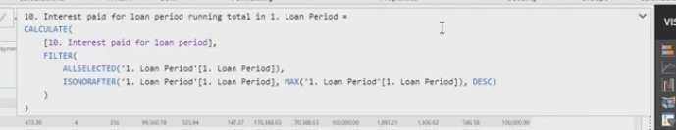

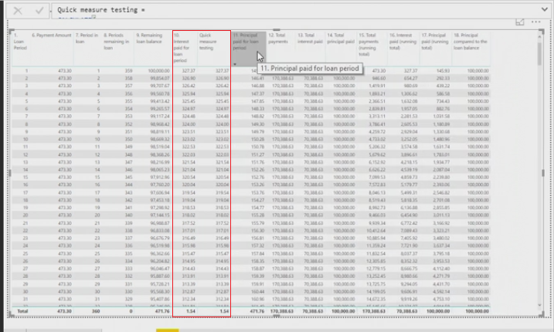

Creating Date table:

Date(year, month, day)

GENERATESERIES(start value, end value, interval)

GENERATESERIES(Date(year, month, day), Date(end year, end month, end day))

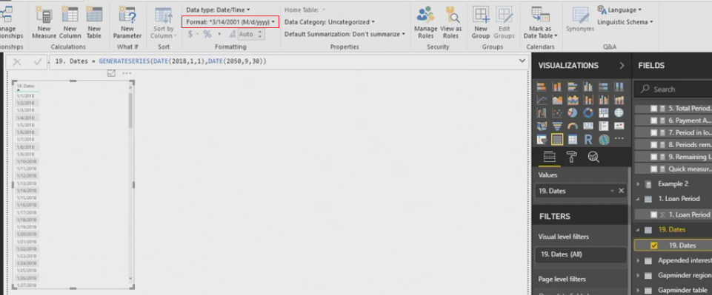

How would you create a date table in Power BI for mortgage loan calculations, rather than loan periods that will use dates as the pivot coordinates?

**Use the formula GENERATESERIES(DATE(start year, start month, start day), DATE(end year, end month, end date)).**

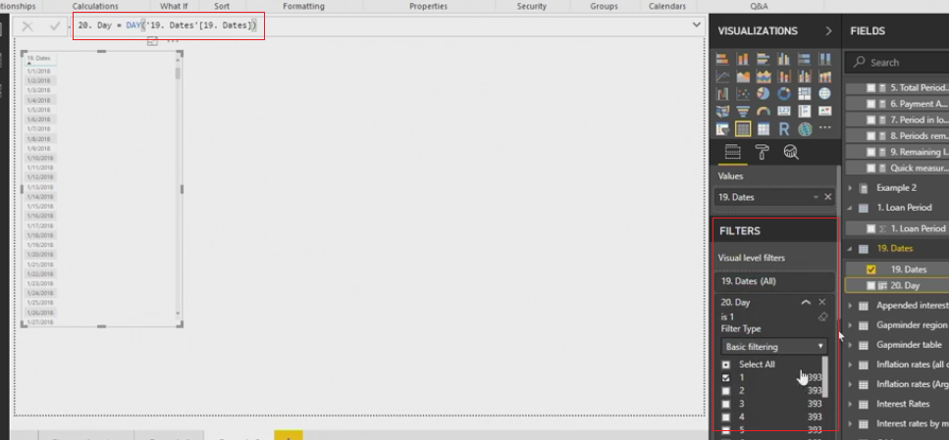

Filter between tables:

1. Pivot coordinates
2. coordinates at the end of CALCULATE functions
3. FILTER functions
4. filtering between tables..

SELECTEDVALUE

= SELECTEDVALUE(column) : establish relationship between tables

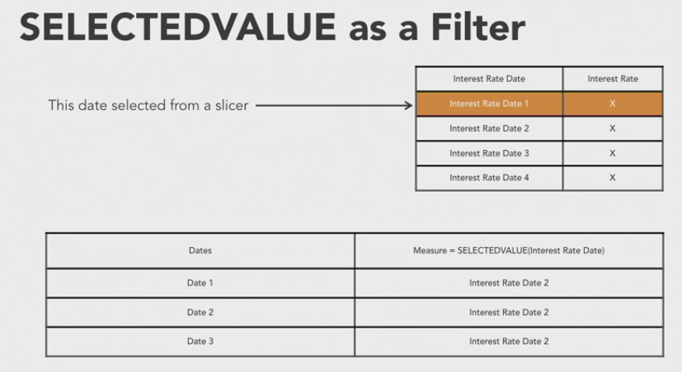

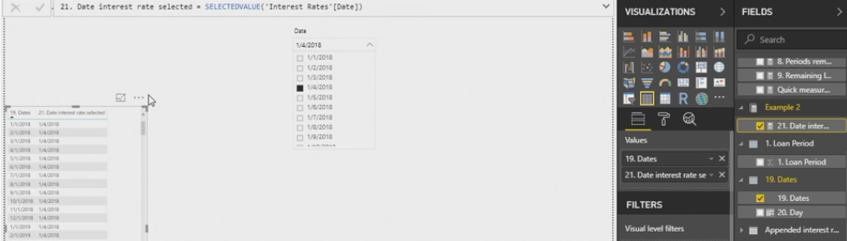

Conditional Function of IF :

=IF (condition 1, <result>,<alternate result>) : These cannot be naked columns

Forecast Date:

Jan to Nov: =DATE(year, month+1, 1)

Dec : =DATE(year+1, 1, 1)

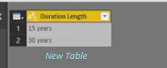

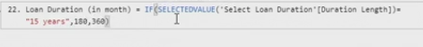

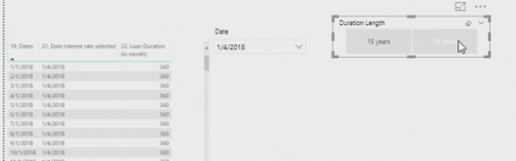

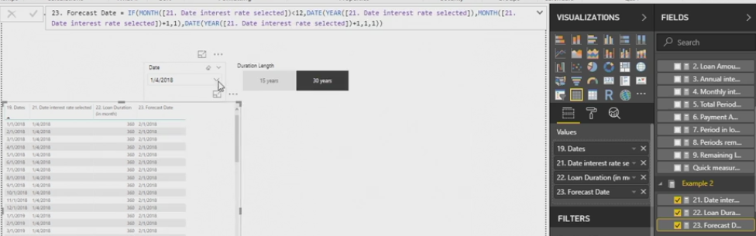

Dynamic Measure

=IF(condition,[measure1],[measure2])

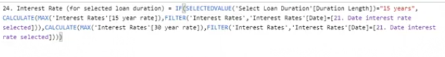

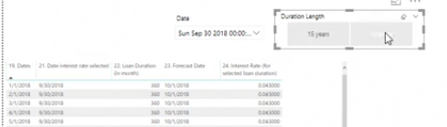

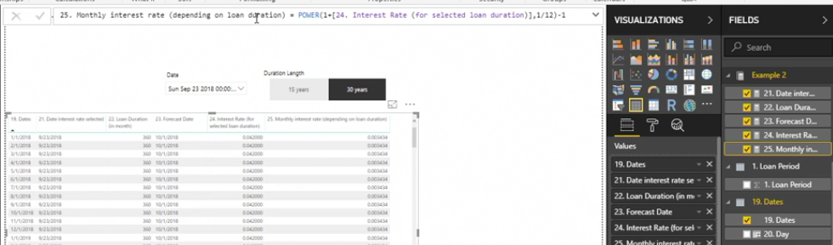

Datediff

=DATEDIFF(start Date, End Date, interval)

start date, End Date : need to be measures, interval : year, month, day

Why would you use the DATEDIFF measure function with mortgage loan pivot table data?

**to calculate the difference between two dates, both of which must be measures, by an interval such as months**

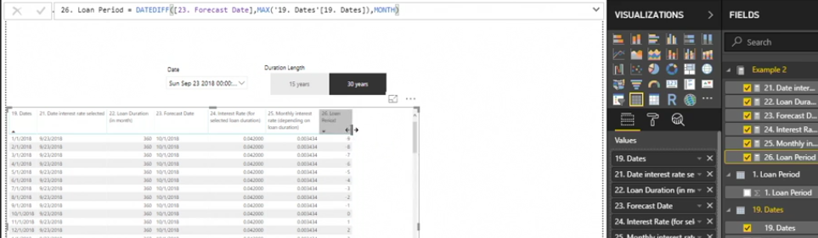

Working with Disconnected tables

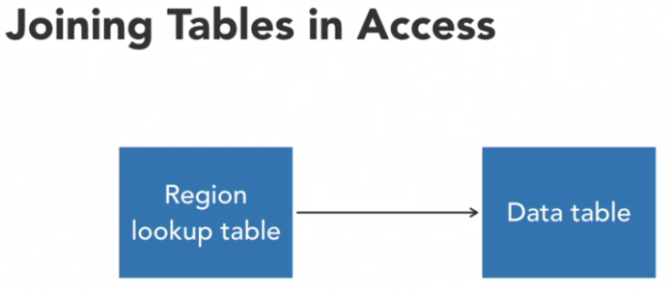

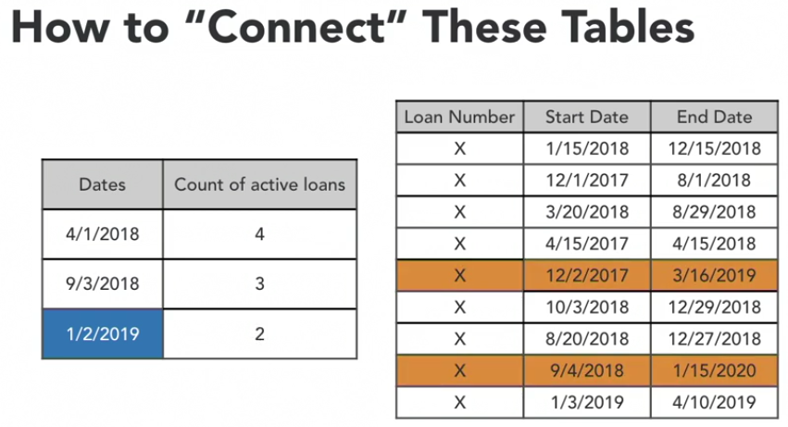

=calculate(count(loans), filter(data table, start date <= date measured && end date >= date measured))

Which two tables, in order, will a DAX CALCULATE formula draw from to connect a loan period table to a dates table?

**the data tables, and the pivot coordinates of the dates table**

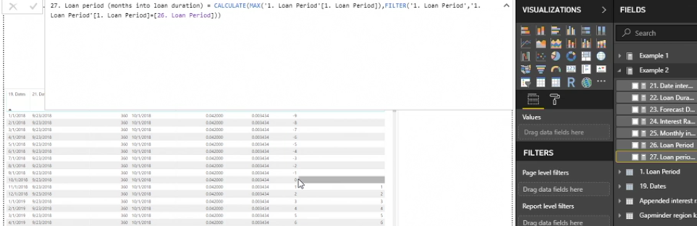

BLANK()

=divide(numerator, denominator, BLANK())

BLANK()=0, shows up as " "

What do you need to consider if you use the BLANK function in Power BI?

**BLANK will also pick up values of zero.**



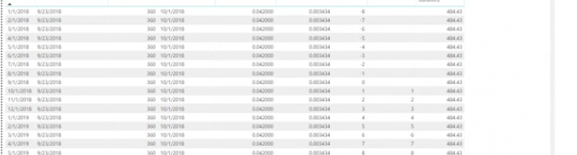

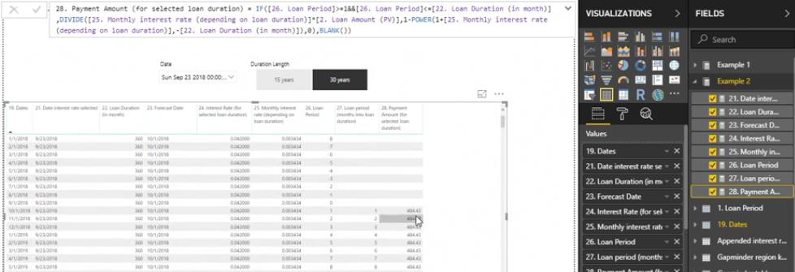

Formulas with Variables:

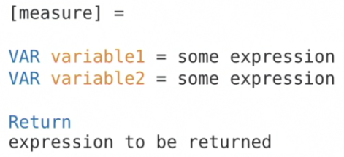

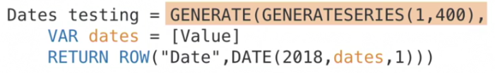

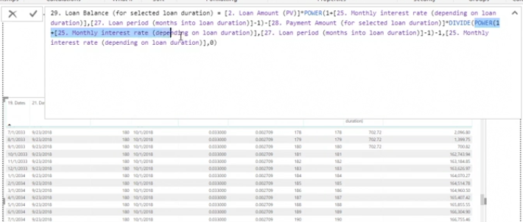

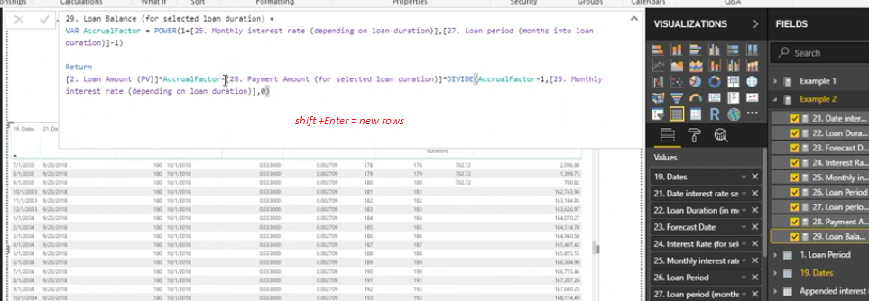

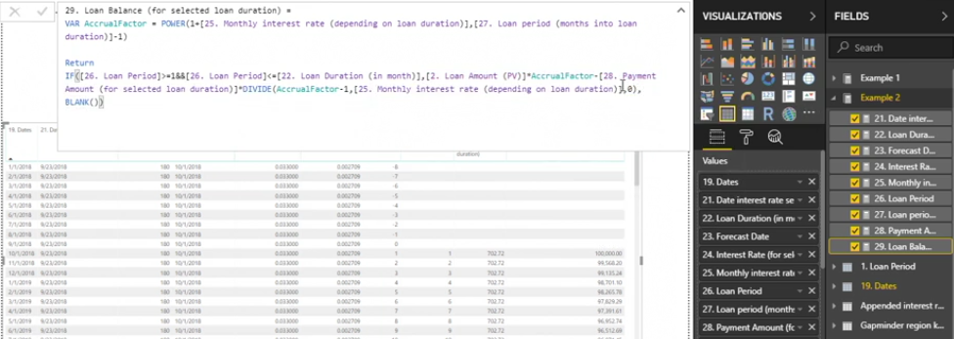

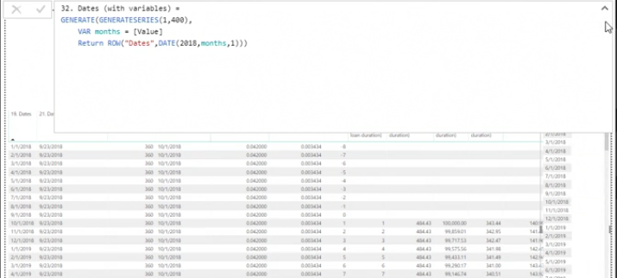

DATESBETWEEN and X functions

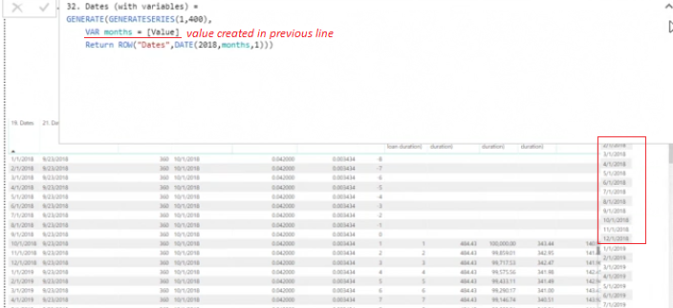

= SumX(table/column, [measure]) *Calculate Running total*

= DATEBETWEEN(dates column, start Date, End Date) *DATEBETWEEN as a FILTER*

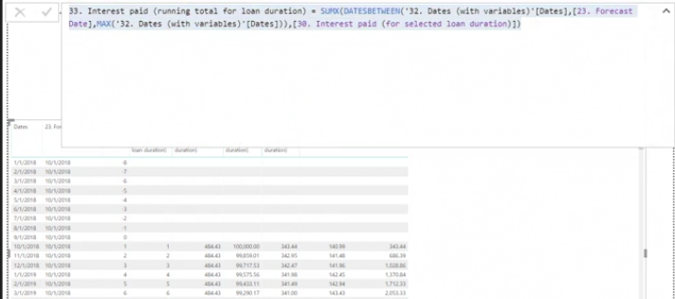

DATEADD

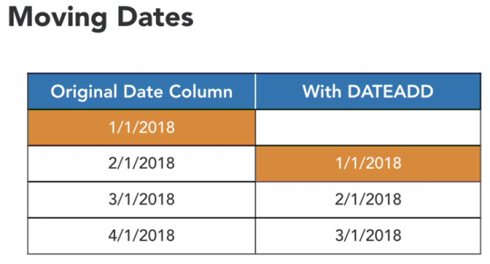

=dateadd(date column, number of units, unit of interval)

: no of unit = 2 , unit of interval = month, day, year

* used in conjunction. cannot be used as a standalone function

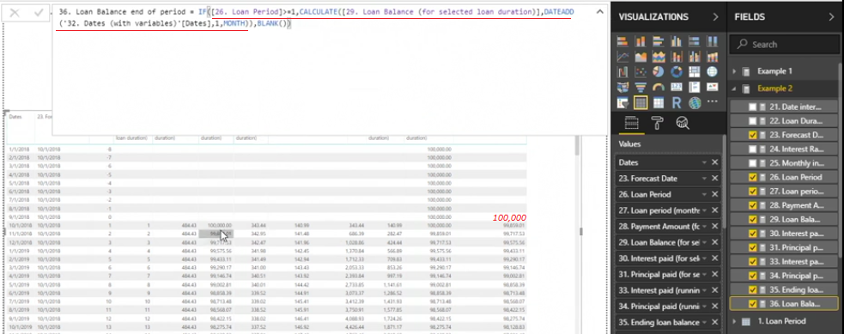

MTD, QTD, YTD

DATESQTD(date column)

DATESYTD(date column)



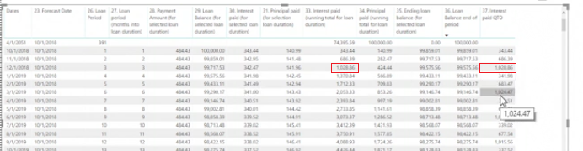

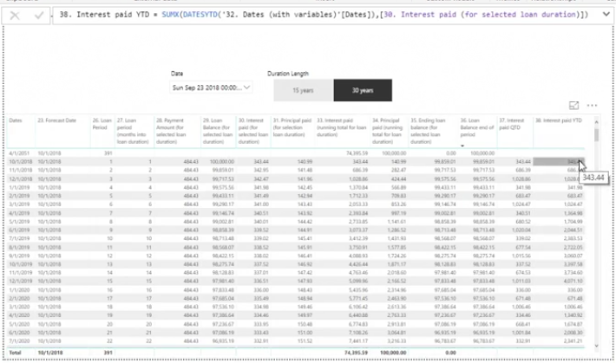

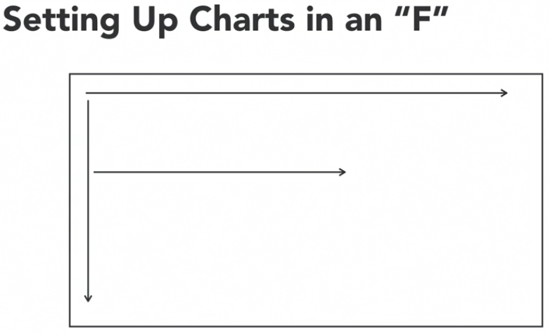

color.adobe.com





PowerBI sharing options:

1. Uploaded to power BI pro
2. Email file
3. Embeded in iFrame